
BAHIRDAR INSTUETE OF TECHNOLY
FACULITY OF COMPUTING
DEPARTMENT OF SOFTWARE ENGINEERING
Individual Assignment – Principles of Compiler Design
Course: Syntax Analysis

Name:BIRTUKAN GETNET
ID: 1505497

1. Objectives of the Assignment

1.1 Understanding Syntax Analysis Concepts
Syntax analysis is a core phase of compiler design that checks whether the source program follows the grammatical rules of the programming language. It works after lexical analysis and before semantic analysis.
The main objectives include:
Understanding the role of syntax analysis in a compiler
Studying Context-Free Grammars (CFGs), including terminals, non-terminals, and production rules
Learning top-down parsing (LL parsing) and bottom-up parsing (LR parsing)
Identifying syntax errors and applying error recovery techniques
Constructing parse trees and Abstract Syntax Trees (ASTs)

1.2 Grammar Analysis Skills
This assignment also aims to develop grammar analysis skills such as:
Identifying left recursion and left factoring in grammars
Computing FIRST and FOLLOW sets
Constructing LL(1) parsing tables
Removing left recursion from grammars
Constructing parse trees for given input strings

1.3 Programming and Implementation
The practical objectives include:
Writing simple lexical scanners for identifiers, keywords, numbers, and operators
Implementing recursive descent parsers
Using stack-based parsers for matching parentheses
Evaluating arithmetic expressions
Removing comments or invalid tokens from input programs

1.4 Problem Solving and Critical Thinking
Applying grammar theory to real parsing problems
Performing syntax validation and expression evaluation
Constructing and verifying parse trees
Verifying the correctness of grammar definitions and parser outputs

1.5 Cognitive and Analytical Skills
Improving attention to grammar rules
Comparing different parsing techniques
Debugging and testing C++ programs
Converting compiler theory into working implementations

1.6 Preparation for Advanced Topics
Building a foundation for semantic analysis, code generation, and compiler optimization
Understanding the interaction between lexical analysis and syntax analysis

2. Theory

2.1 Terminals
Terminals are symbols that appear in the input string and cannot be replaced further.
Example:
{ a, +, *, (, ) }

2.2 Non-Terminals
Non-terminals are symbols used to define the structure of the language. They can be replaced using production rules.
Example:
E → E + T | T
Here, E and T are non-terminals.

3. Programming (C++): Binary String Validation
The following C++ program checks whether a given input string is a valid binary string (contains only 0 and 1). This program demonstrates basic syntax checking similar to lexical validation in compiler design.
Note: The source file must be saved with the .cpp extension and compiled using a C++ compiler such as g++.

3.1 C++ Source Code
#include <iostream>
#include <string>
using namespace std;

// Function to validate a binary string
bool isValidBinary(const string& str) {
for (char ch : str) {
if (ch != '0' && ch != '1') {
return false; // Invalid character found
}
}
return true; // All characters are '0' or '1'
}

int main() {
string input;
cout << "Enter a binary string: ";
cin >> input;

if (isValidBinary(input)) {
cout << "Valid binary string." << endl;
} else {
cout << "Invalid binary string. Only '0' and '1' are allowed." << endl;
}
return 0;
}

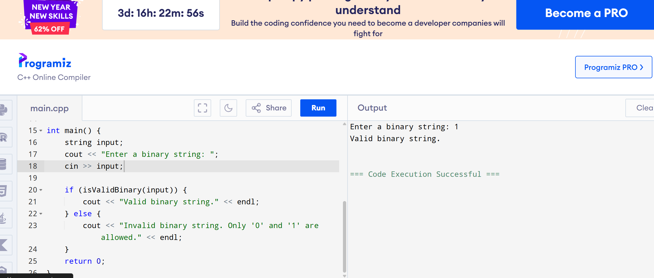

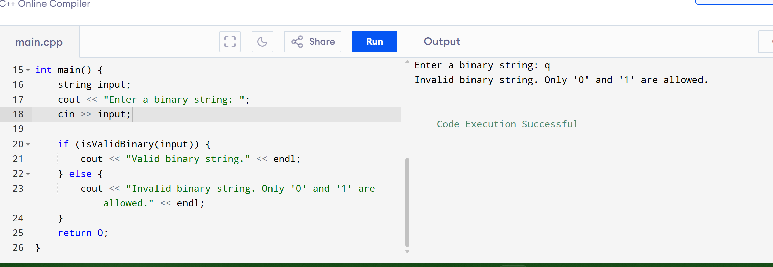

3.2 Explanation
The program reads a string from the user
Each character is checked to ensure it is either 0 or 1
If any invalid character is found, the string is rejected
Otherwise, the string is accepted as a valid binary string
This simulates lexical-level validation before syntax analysis.

4. Problem-Solving: Parse Tree Construction

Grammar
S → aSa | bSb | c

Input String
"cbc"

Derivation
S → c

Parse Tree
S
|
c
The input string "cbc" reduces directly to the terminal c, which satisfies the grammar rule S → c.

5. Conclusion
In this assignment:
Key concepts of syntax analysis were discussed
Terminals and non-terminals were clearly defined
A runnable C++ program for binary string validation was implemented
A parse tree was constructed for a given grammar and input string
This assignment provides a strong foundation for advanced compiler topics such as semantic analysis, code generation, and optimization.
ndation for semantic analysis, code generation, compiler optimization
Understand interplay between lexical and syntax analysis

2. Theory
Terminals: Symbols that appear in the input string and cannot be replaced.
Example: { a, +, *, (, ) }
Non-terminals: Symbols used to define the language structure. They can be replaced using productions.
Example: E → E + T | T, here E and T are non-terminals.

3. Programming (C++): Validate Binary Strings
#include <iostream>
#include <string>
using namespace std;

// Function to validate a binary string
bool isValidBinary(const string& str) {
for (char ch : str) {
if (ch != '0' && ch != '1') {
return false; // Invalid character found
}
}
return true; // All characters are '0' or '1'
}

int main() {
string input;
cout << "Enter a binary string: ";
cin >> input;

if (isValidBinary(input)) {
cout << "Valid binary string." << endl;
} else {
cout << "Invalid binary string. Only '0' and '1' are allowed." << endl;
}
return 0;
}

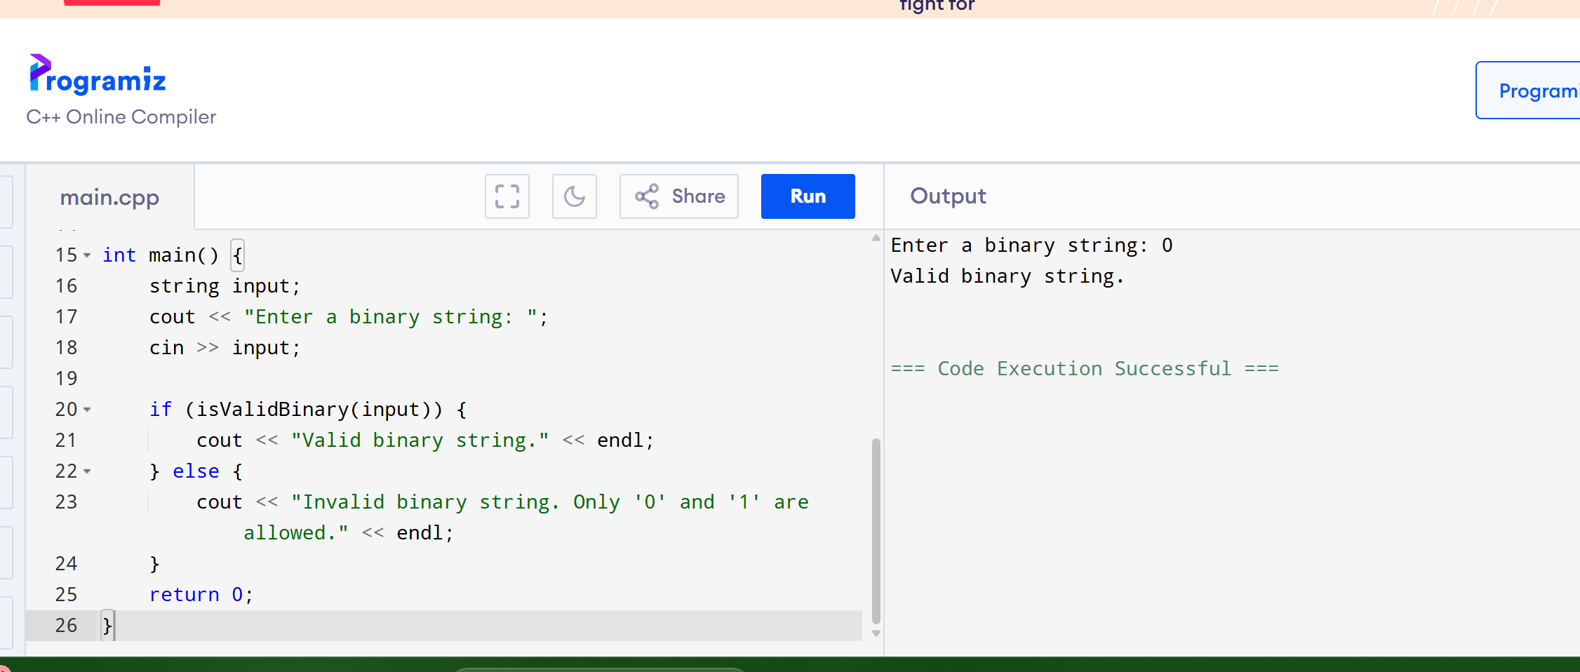

Explanation: Iterates through each character, checks for '0' or '1', prints validity.

4. Problem-Solving: Parse Tree
Grammar:
S → aSa | bSb | c
Input String: "cbc"
Parse Tree:
S
|
c

5. Conclusion
Demonstrated syntax analysis concepts.
Defined terminals and non-terminals.
Implemented C++ binary string validation.
Constructed parse tree for the given grammar.
Prepared a foundation for advanced compiler topics.

